Figure 7
Connections over 200 kbps in at Least One Direction 2011-2015
(In thousands)

 | 2011 |  | 2012 |  | 2013 |  | 2014 |  | 2015
Technology | Jun | Dec | Jun | Dec | Jun | Dec | Jun* | Dec | Jun
Total | 206,131 | 230,201 | 243,359 | 262,564 | 284,692 | 293,397 | 311,284 | 321,305 | 341,648
Total Fixed | 86,575 | 88,317 | 89,945 | 92,511 | 93,986 | 96,032 | 95,998 | 97,810 | 99,686
Mobile Wireless | 119,556 | 141,883 | 153,414 | 170,053 | 190,706 | 197,365 | 215,286 | 223,495 | 241,962

Figure 8
Residential Connections over 200 kbps in at Least One Direction 2011-2015
(In thousands)

 | 2011 |  | 2012 |  | 2013 |  | 2014 |  | 2015
Technology | Jun | Dec | Jun | Dec | Jun | Dec | Jun* | Dec | Jun
Total | 171,773 | 186,516 | 196,665 | 215,817 | 235,273 | 246,797 | 264,343 | 273,950 | 291,919
Total Fixed | 78,906 | 80,706 | 82,217 | 84,392 | 85,277 | 87,599 | 87,360 | 89,196 | 91,059
Mobile Wireless | 92,867 | 105,810 | 114,448 | 131,425 | 149,996 | 159,197 | 176,983 | 184,754 | 200,859

* The June 2014 data have not been subjected to the typical quality checks (see Technical Notes).

The Commission approved changes to the Form 477 in June 2013 that affect the data beginning in June 2014 (see Technical Notes). Some previously-published
data may have been revised. Figures may not sum to totals elsewhere in this report due to rounding.

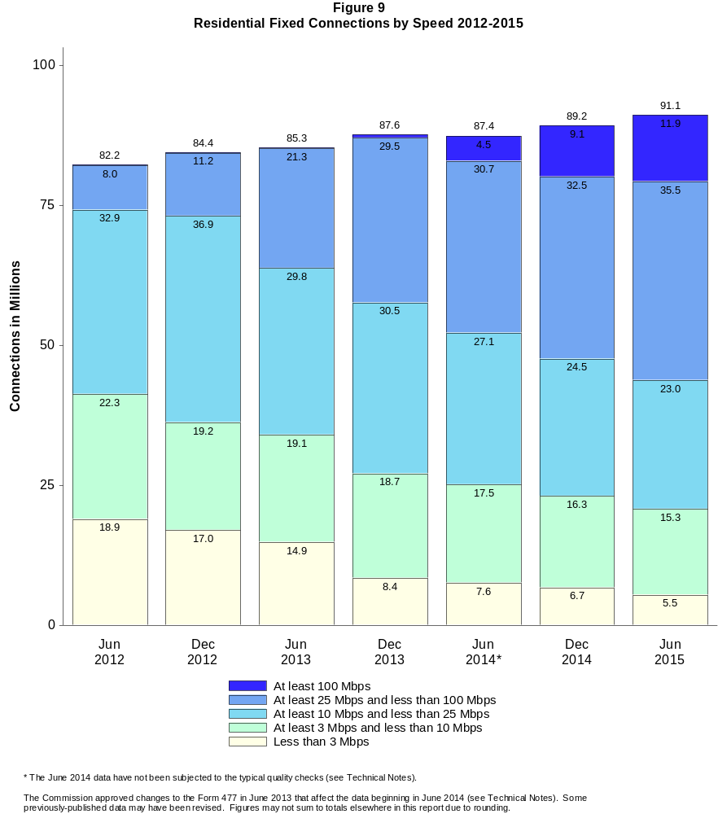

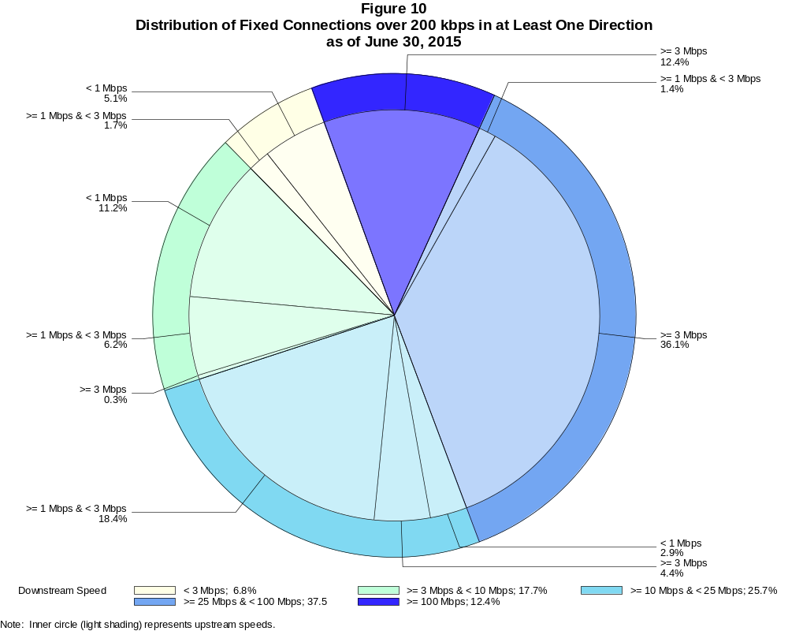

Fixed Connections over 200 kbps in at Least One Direction (in thousands)

 | Downstream Speed
Upstream Speed | Less than 3 Mbps | At least 3 Mbps  and less than 10 Mbps | At least 10 Mbps  and less than 25 Mbps | At least 25 Mbps  and less than 100 Mbps | At least 100 Mbps | Total
Less than 1 Mbps | 5,044 | 11,170 | 2,900 | 2 | # | 19,116
At least 1 Mbps & Less than 3 Mbps | 1,695 | 6,154 | 18,334 | 1,351 | 2 | 27,537
At least 3 Mbps | 13 | 320 | 4,377 | 36,011 | 12,313 | 53,033
Total | 6,753 | 17,644 | 25,611 | 37,364 | 12,315 | 99,686

Percentages

Less than 1 Mbps | 5.1 | 11.2 | 2.9 | 0.0 | 0.0 | 19.2
At least 1 Mbps & Less than 3 Mbps | 1.7 | 6.2 | 18.4 | 1.4 | 0.0 | 27.6
At least 3 Mbps | 0.0 | 0.3 | 4.4 | 36.1 | 12.4 | 53.2
Total | 6.8 | 17.7 | 25.7 | 37.5 | 12.4 | 100.0

Note: Figures may not sum to totals due to rounding.
Source: FCC Form 477.

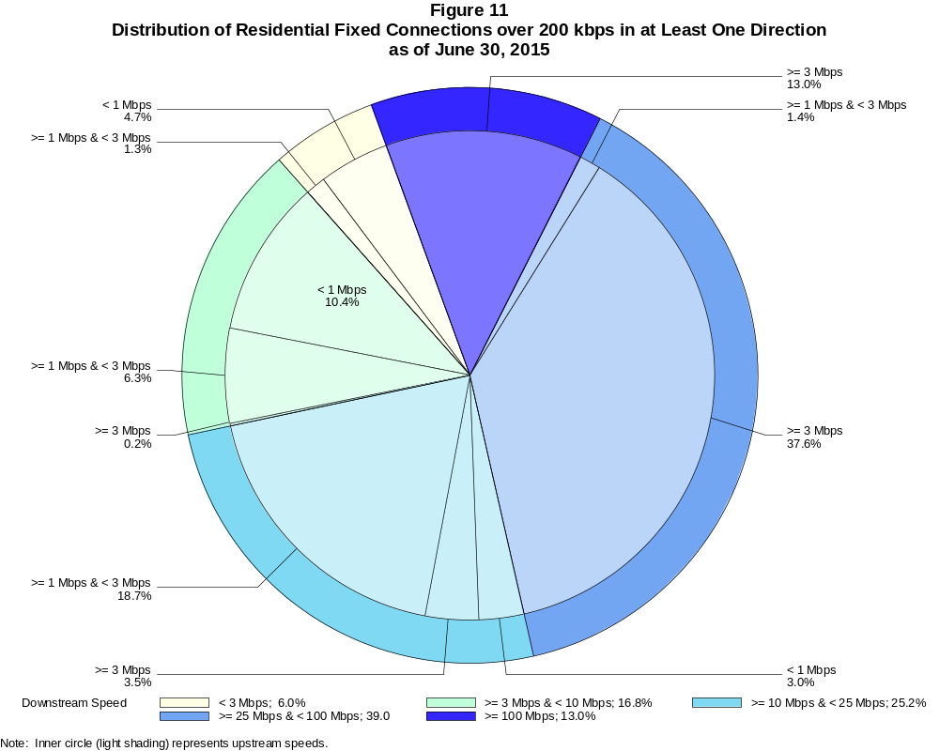

Residential Fixed Connections over 200 kbps in at Least One Direction (in thousands)

 | Downstream Speed
Upstream Speed | Less than 3 Mbps | At least 3 Mbps  and less than 10 Mbps | At least 10 Mbps  and less than 25 Mbps | At least 25 Mbps  and less than 100 Mbps | At least 100 Mbps | Total
Less than 1 Mbps | 4,249 | 9,425 | 2,706 | 2 | # | 16,382
At least 1 Mbps & Less than 3 Mbps | 1,190 | 5,700 | 17,068 | 1,264 | # | 25,222
At least 3 Mbps | 12 | 151 | 3,206 | 34,232 | 11,854 | 49,455
Total | 5,451 | 15,275 | 22,981 | 35,498 | 11,854 | 91,059

Percentages

Less than 1 Mbps | 4.7 | 10.4 | 3.0 | 0.0 | 0.0 | 18.0
At least 1 Mbps & Less than 3 Mbps | 1.3 | 6.3 | 18.7 | 1.4 | 0.0 | 27.7
At least 3 Mbps | 0.0 | 0.2 | 3.5 | 37.6 | 13.0 | 54.3
Total | 6.0 | 16.8 | 25.2 | 39.0 | 13.0 | 100.0

Note: Figures may not sum to totals due to rounding.
Source: FCC Form 477.

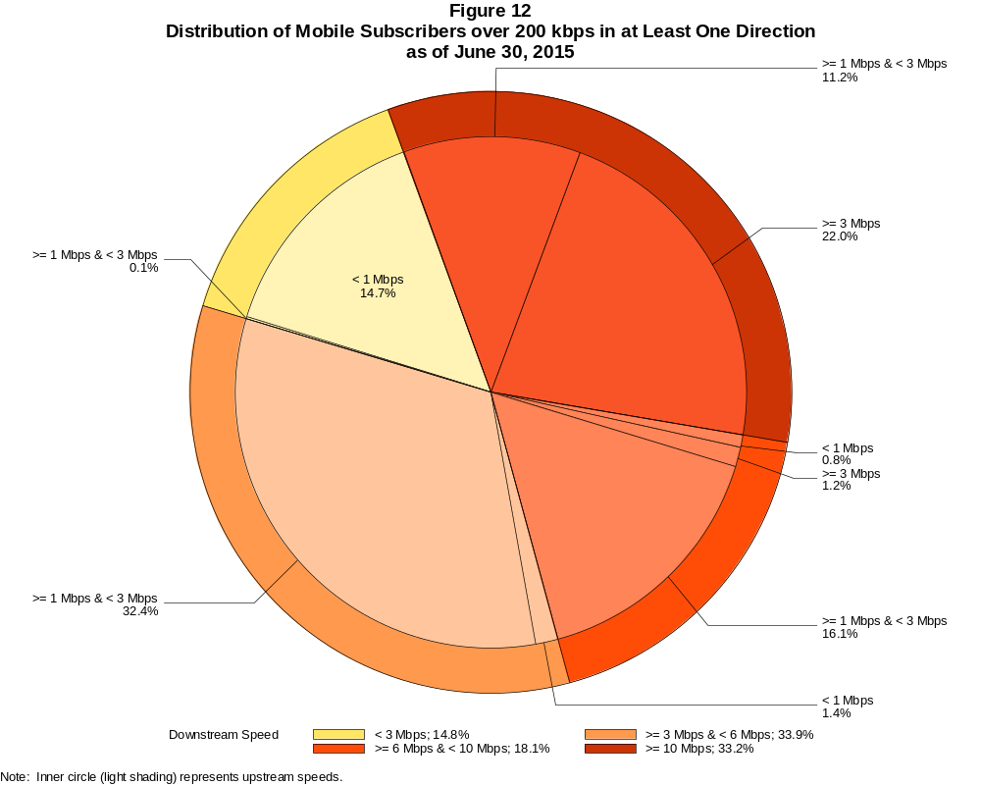

Mobile Subscribers over 200 kbps in at Least One Direction (in thousands)

 | Downstream Speed
Upstream Speed | Less than 3 Mbps | At least 3 Mbps  and less than 6 Mbps | At least 6 Mbps  and less than 10 Mbps | At least 10 Mbps | Total
Less than 1 Mbps | 35,469 | 3,403 | 1,907 | 78 | 40,857
At least 1 Mbps & Less than 3 Mbps | 337 | 78,516 | 38,932 | 27,071 | 144,855
At least 3 Mbps | 0 | 31 | 2,993 | 53,226 | 56,250
Total | 35,805 | 81,949 | 43,832 | 80,375 | 241,962

Percentages

Less than 1 Mbps | 14.7 | 1.4 | 0.8 | 0.0 | 16.9
At least 1 Mbps & Less than 3 Mbps | 0.1 | 32.4 | 16.1 | 11.2 | 59.9
At least 3 Mbps | 0.0 | 0.0 | 1.2 | 22.0 | 23.2
Total | 14.8 | 33.9 | 18.1 | 33.2 | 100.0

Note: Figures may not sum to totals due to rounding.
Source: FCC Form 477.

Figure 13
Connections over 200 kbps in at Least One Direction by Technology 2011-2015
(In thousands)

 | 2011 |  | 2012 |  | 2013 |  | 2014 |  | 2015
Technology | Jun | Dec | Jun | Dec | Jun | Dec | Jun* | Dec | Jun
Total | 206,131 | 230,201 | 243,359 | 262,564 | 284,692 | 293,397 | 311,284 | 321,305 | 341,648
Total Fixed | 86,575 | 88,317 | 89,945 | 92,511 | 93,986 | 96,032 | 95,998 | 97,810 | 99,686
aDSL | 31,611 | 31,330 | 31,173 | 30,974 | 30,657 | 30,690 | 29,873 | 28,527 | 28,194
sDSL | 159 | 148 | 139 | 132 | 117 | 108 | 96 | 85 | 76
Other Wireline¹ | 778 | 795 | 770 | 796 | 769 | 772 | 792 | 723 | 701
Cable Modem | 46,698 | 48,263 | 49,664 | 51,646 | 52,760 | 54,009 | 54,011 | 56,301 | 57,850
FTTP² | 5,477 | 5,898 | 6,300 | 6,733 | 7,250 | 7,745 | 8,326 | 9,180 | 9,768
Satellite | 1,204 | 1,190 | 1,217 | 1,454 | 1,623 | 1,849 | 1,964 | 2,006 | 2,058
Fixed Wireless | 649 | 693 | 682 | 777 | 810 | 858 | 935 | 988 | 1,040
Mobile Wireless | 119,556 | 141,883 | 153,414 | 170,053 | 190,706 | 197,365 | 215,286 | 223,495 | 241,962

¹ Power Line and Other are summarized with Other Wireline to maintain firm confidentiality. See Technical Notes at the end of the report for a description of
Form 477 technology categories and other reporting requirements.
² Fiber to the premises.
* The June 2014 data have not been subjected to the typical quality checks (see Technical Notes).

The Commission approved changes to the Form 477 in June 2013 that affect the data beginning in June 2014 (see Technical Notes). Some previously-published data may
have been revised. Figures may not sum to totals due to rounding.

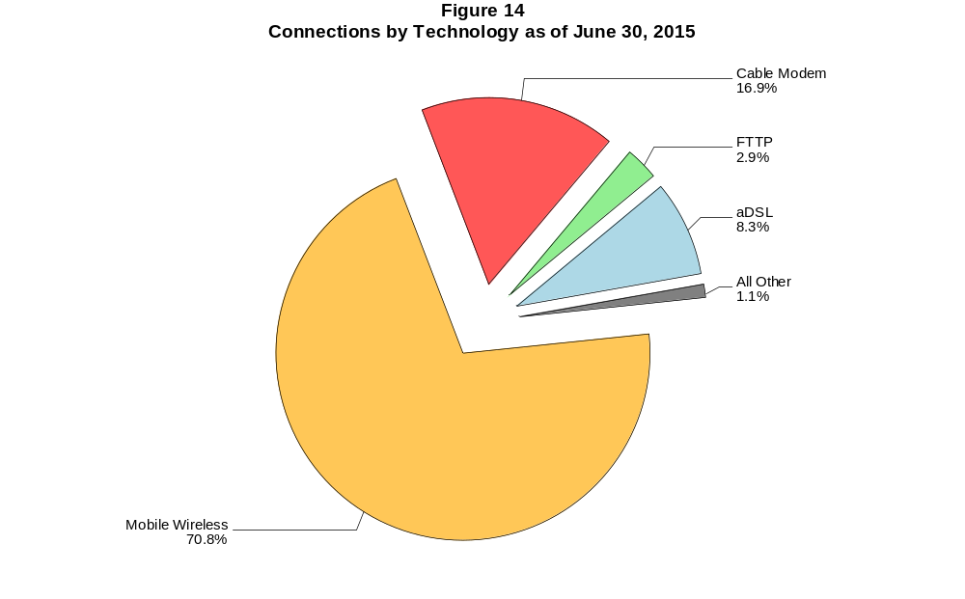

Figure 15
Residential Connections over 200 kbps in at Least One Direction by Technology 2011-2015
(In thousands)

 | 2011 |  | 2012 |  | 2013 |  | 2014 |  | 2015
Technology | Jun | Dec | Jun | Dec | Jun | Dec | Jun* | Dec | Jun
Total | 171,773 | 186,516 | 196,665 | 215,817 | 235,273 | 246,797 | 264,343 | 273,950 | 291,919
Total Fixed | 78,906 | 80,706 | 82,217 | 84,392 | 85,277 | 87,599 | 87,360 | 89,196 | 91,059
aDSL | 27,754 | 27,758 | 27,632 | 27,391 | 26,869 | 27,248 | 26,678 | 25,603 | 25,265
sDSL | 52 | 54 | 49 | 50 | 43 | 39 | 30 | 22 | 17
Other Wireline¹ | 45 | 40 | 14 | 34 | 22 | 22 | 57 | 59 | 52
Cable Modem | 44,480 | 45,832 | 47,033 | 48,716 | 49,494 | 50,709 | 50,389 | 52,467 | 54,023
FTTP² | 5,118 | 5,521 | 5,892 | 6,270 | 6,732 | 7,176 | 7,617 | 8,368 | 8,897
Satellite | 885 | 886 | 998 | 1,242 | 1,407 | 1,643 | 1,760 | 1,803 | 1,875
Fixed Wireless | 572 | 616 | 600 | 689 | 710 | 763 | 829 | 874 | 929
Mobile Wireless | 92,867 | 105,810 | 114,448 | 131,425 | 149,996 | 159,197 | 176,983 | 184,754 | 200,859

¹ Power Line and Other are summarized with Other Wireline to maintain firm confidentiality. See Technical Notes at the end of the report for a description of
Form 477 technology categories and other reporting requirements.
² Fiber to the premises.
* The June 2014 data have not been subjected to the typical quality checks (see Technical Notes).

The Commission approved changes to the Form 477 in June 2013 that affect the data beginning in June 2014 (see Technical Notes). Some previously-published data may
have been revised. Figures may not sum to totals due to rounding.

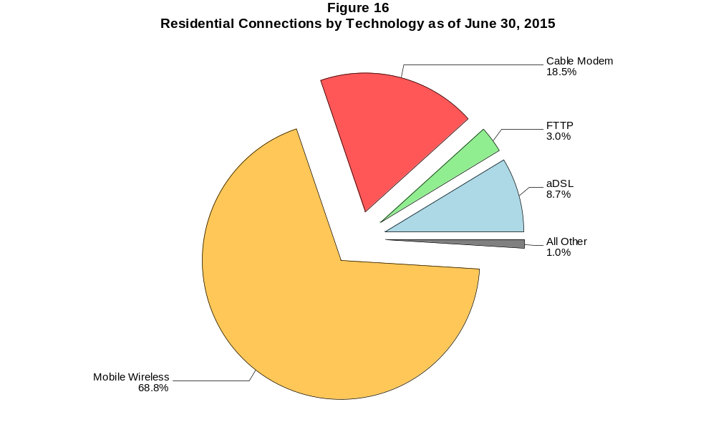

Figure 17
Fixed Connections at Least 3 Mbps Downstream and 768 kbps Upstream by Technology 2011-2015
(In thousands)

 | 2011 |  | 2012 |  | 2013 |  | 2014 |  | 2015
Technology | Jun | Dec | Jun | Dec | Jun | Dec | Jun* | Dec | Jun
Total | 48,577 | 51,097 | 57,243 | 64,657 | 68,673 | 78,175 | 78,981 | 83,872 | 87,556
aDSL | 8,909 | 10,351 | 12,875 | 13,108 | 14,233 | 18,540 | 17,246 | 18,557 | 19,319
sDSL | 16 | 26 | 30 | 33 | 34 | 36 | 33 | 28 | 24
Other Wireline¹ | 204 | 228 | 239 | 276 | 284 | 308 | 310 | 308 | 297
Cable Modem | 34,113 | 34,699 | 37,798 | 44,133 | 46,014 | 50,236 | 51,304 | 53,853 | 55,978
FTTP² | 5,188 | 5,606 | 6,001 | 6,430 | 6,981 | 7,486 | 8,111 | 8,974 | 9,580
Satellite | # | # | 87 | 394 | 791 | 1,181 | 1,424 | 1,558 | 1,690
Fixed Wireless | 145 | 186 | 214 | 284 | 337 | 388 | 553 | 594 | 669

¹ Power Line and Other are summarized with Other Wireline to maintain firm confidentiality. See Technical Notes at the end of the report for a description of Form
technology categories and other reporting requirements.
² Fiber to the premises.
* The June 2014 data have not been subjected to the typical quality checks (see Technical Notes).
# = Rounds to zero.

The Commission approved changes to the Form 477 in June 2013 that affect the data beginning in June 2014 (see Technical Notes). Some previously-published
data may have been revised. Figures may not sum to totals due to rounding.

Figure 18
Residential Fixed Connections at Least 3 Mbps Downstream and 768 kbps Upstream by Technology 2011-2015
(In thousands)

 | 2011 |  | 2012 |  | 2013 |  | 2014 |  | 2015
Technology | Jun | Dec | Jun | Dec | Jun | Dec | Jun* | Dec | Jun
Total | 45,263 | 47,427 | 53,070 | 59,914 | 63,342 | 72,476 | 73,042 | 77,540 | 81,013
aDSL | 7,909 | 9,274 | 11,563 | 11,669 | 12,666 | 16,715 | 15,673 | 16,867 | 17,536
sDSL | 4 | 12 | 12 | 13 | 13 | 13 | 7 | 2 | 1
Other Wireline¹ | 15 | 16 | 7 | 20 | 21 | 20 | 45 | 50 | 45
Cable Modem | 32,321 | 32,693 | 35,583 | 41,561 | 43,061 | 47,258 | 47,924 | 50,308 | 52,371
FTTP² | 4,894 | 5,271 | 5,632 | 6,012 | 6,504 | 6,958 | 7,491 | 8,246 | 8,789
Satellite | 0 | # | 86 | 393 | 788 | 1,177 | 1,419 | 1,552 | 1,682
Fixed Wireless | 121 | 161 | 185 | 245 | 289 | 335 | 483 | 516 | 588

¹ Power Line and Other are summarized with Other Wireline to maintain firm confidentiality. See Technical Notes at the end of the report for a description of Form
technology categories and other reporting requirements.
² Fiber to the premises.
* The June 2014 data have not been subjected to the typical quality checks (see Technical Notes).
# = Rounds to zero.

The Commission approved changes to the Form 477 in June 2013 that affect the data beginning in June 2014 (see Technical Notes). Some previously-published
data may have been revised. Figures may not sum to totals due to rounding.

Figure 19
Fixed Connections at Least 10 Mbps Downstream and 1 Mbps Upstream by Technology 2014-2015
(In thousands)

 | 2014 |  | 2015
Technology | Jun* | Dec | Jun
Total | 35,927 | 68,009 | 72,387
aDSL | 420 | 8,310 | 9,141
sDSL | 2 | 6 | 8
Other Wireline¹ | 114 | 183 | 182
Cable Modem | 30,769 | 49,839 | 52,708
FTTP² | 4,603 | 8,341 | 8,830
Satellite | # | 1,137 | 1,298
Fixed Wireless | 19 | 192 | 219

¹ Power Line and Other are summarized with Other Wireline to maintain firm confidentiality. See Technical Notes at the end of the report for a description of
Form 477 technology categories and other reporting requirements.
² Fiber to the premises.
* The June 2014 data have not been subjected to the typical quality checks (see Technical Notes).
# = Rounds to zero.

The Commission approved changes to the Form 477 in June 2013 that affect the data beginning in June 2014 (see Technical Notes).
Figures may not sum to totals due to rounding.

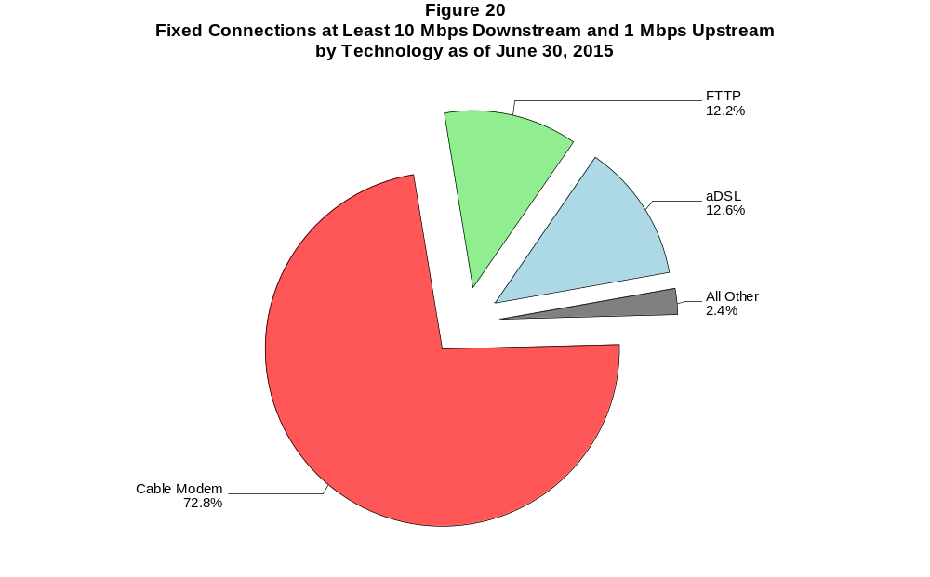

Figure 21
Residential Fixed Connections at Least 10 Mbps Downstream and 1 Mbps Upstream by Technology in 2015
(In thousands)

 | 2014 |  | 2015
Technology | Jun* | Dec | Jun
Total | 34,439 | 63,522 | 67,625
aDSL | 397 | 7,741 | 8,462
sDSL | # | # | #
Other Wireline¹ | 22 | 36 | 38
Cable Modem | 29,806 | 46,767 | 49,526
FTTP² | 4,201 | 7,679 | 8,114
Satellite | 0 | 1,133 | 1,293
Fixed Wireless | 14 | 166 | 190

¹ Power Line and Other are summarized with Other Wireline to maintain firm confidentiality. See Technical Notes at the end of the report for a description of
Form 477 technology categories and other reporting requirements.
² Fiber to the premises.
* The June 2014 data have not been subjected to the typical quality checks (see Technical Notes).
# = Rounds to zero.

The Commission approved changes to the Form 477 in June 2013 that affect the data beginning in June 2014 (see Technical Notes).
Figures may not sum to totals due to rounding.

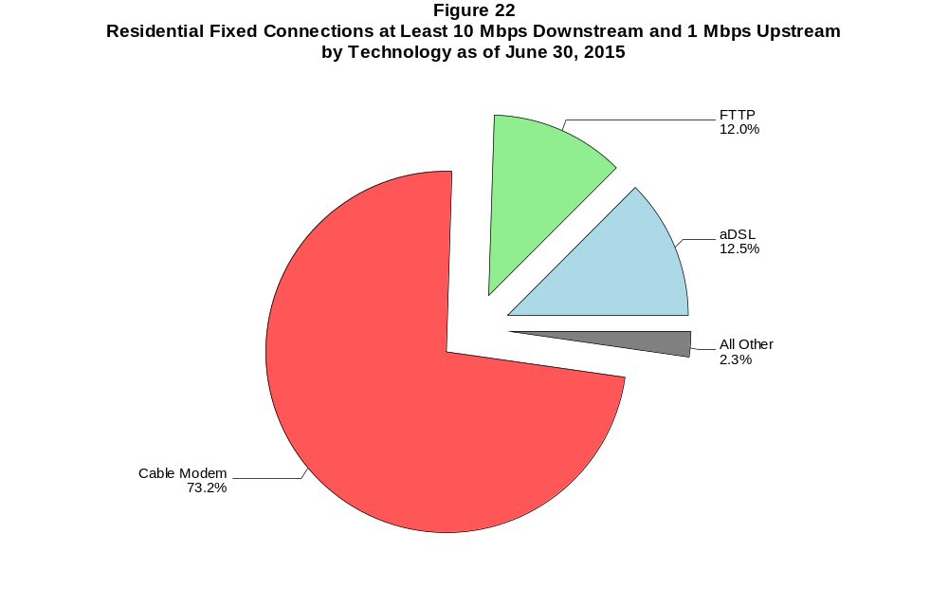

Figure 23
Fixed Connections at Least 25 Mbps Downstream and 3 Mbps Upstream by Technology 2014-2015
(In thousands)

 | 2014 |  | 2015
Technology | Jun* | Dec | Jun
Total | 35,927 | 42,390 | 48,323
aDSL | 420 | 598 | 756
sDSL | 2 | 2 | 1
Other Wireline¹ | 114 | 125 | 125
Cable Modem | 30,769 | 36,095 | 40,652
FTTP² | 4,603 | 5,542 | 6,742
Satellite | # | # | #
Fixed Wireless | 19 | 28 | 47

¹ Power Line and Other are summarized with Other Wireline to maintain firm confidentiality. See Technical Notes at the end of the report for a description of
Form 477 technology categories and other reporting requirements.
² Fiber to the premises.
* The June 2014 data have not been subjected to the typical quality checks (see Technical Notes).
# = Rounds to zero.

The Commission approved changes to the Form 477 in June 2013 that affect the data beginning in June 2014 (see Technical Notes).
Figures may not sum to totals due to rounding.

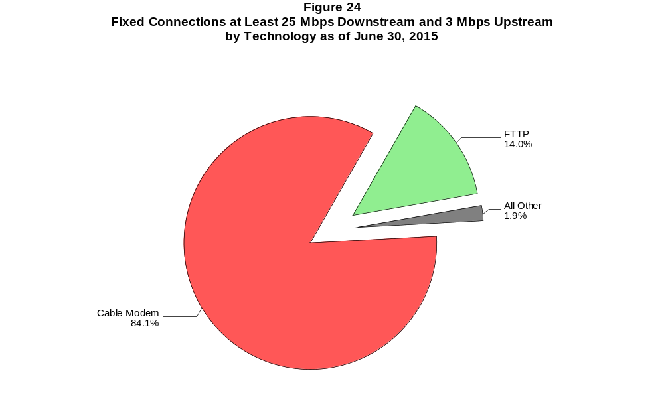

Figure 25
Residential Fixed Connections at Least 25 Mbps Downstream and 3 Mbps Upstream by Technology in 2015
(In thousands)

 | 2014 |  | 2015
Technology | Jun* | Dec | Jun
Total | 34,439 | 40,595 | 46,086
aDSL | 397 | 566 | 723
sDSL | # | # | #
Other Wireline¹ | 22 | 26 | 26
Cable Modem | 29,806 | 34,914 | 39,089
FTTP² | 4,201 | 5,068 | 6,209
Satellite | 0 | 0 | 0
Fixed Wireless | 14 | 22 | 40

¹ Power Line and Other are summarized with Other Wireline to maintain firm confidentiality. See Technical Notes at the end of the report for a description of
Form 477 technology categories and other reporting requirements.
² Fiber to the premises.
* The June 2014 data have not been subjected to the typical quality checks (see Technical Notes).
# = Rounds to zero.

The Commission approved changes to the Form 477 in June 2013 that affect the data beginning in June 2014 (see Technical Notes).
Figures may not sum to totals due to rounding.

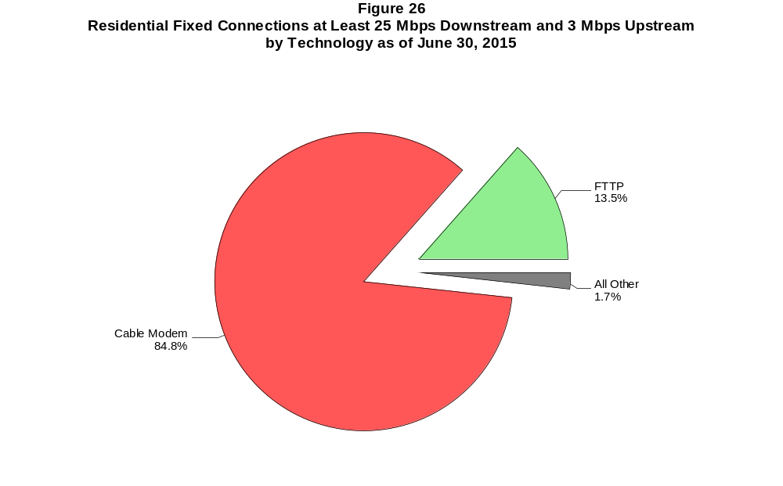

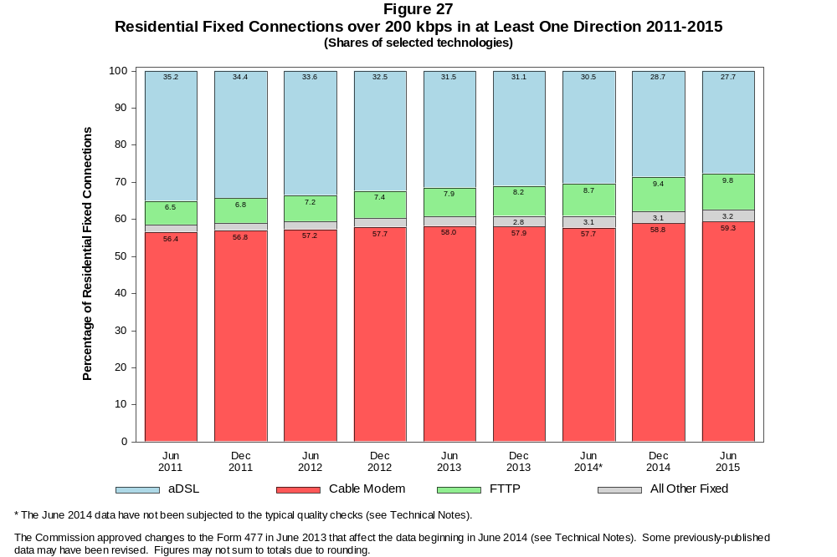

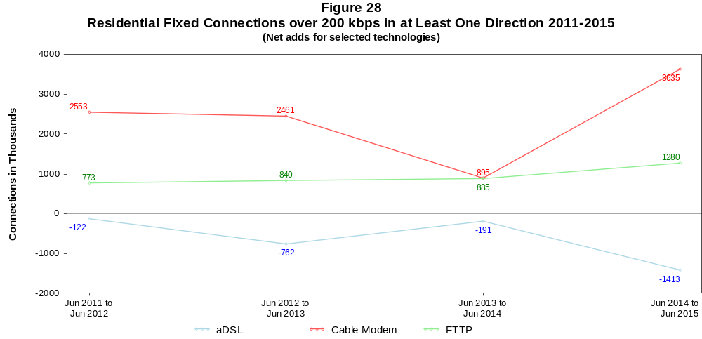

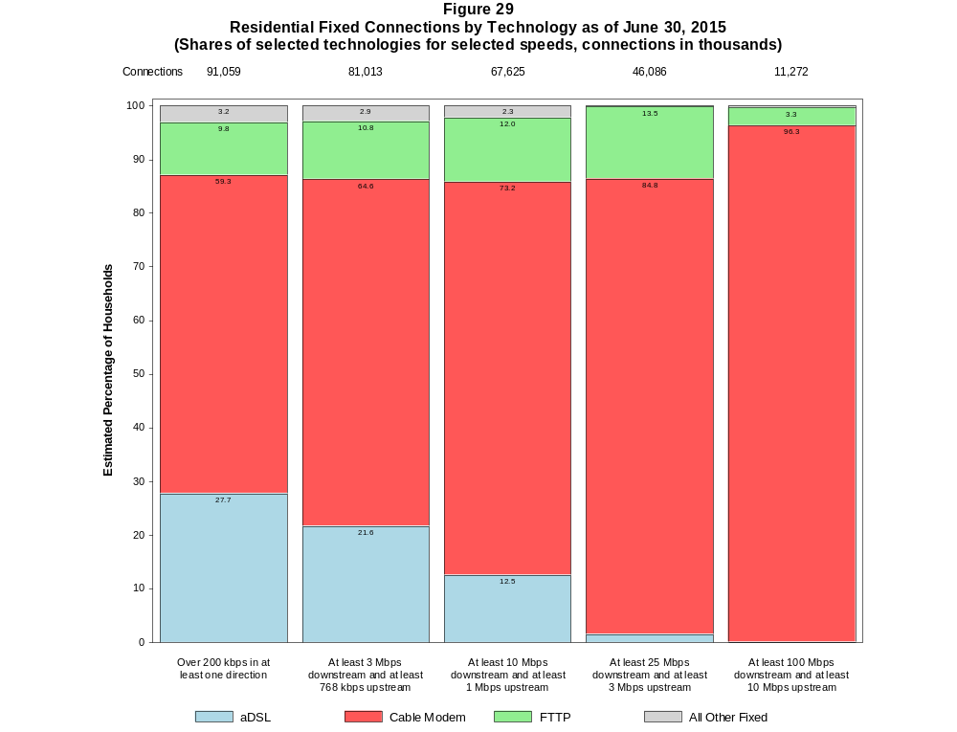

Figure 30
Fixed Connections by Downstream Speed Tier and Technology as of June 30, 2015
(In thousands)

 | Downstream Speed
Technology | Less than  1.5 Mbps | At least 1.5 Mbps  and less than  3 Mbps | At least 3 Mbps  and less than  10 Mbps | At least 10 Mbps  and less than  25 Mbps | At least 25 Mbps  and less than  100 Mbps | At least 100 Mbps | Total
aDSL | 1,698 | 2,852 | 11,932 | 10,834 | 875 | 3 | 28,194
sDSL | 35 | 17 | 16 | 7 | * | * | 76
Other Wireline¹ | 58 | 344 | 118 | 56 | 25 | 101 | 701
Cable Modem | 196 | 768 | 4,033 | 11,009 | 30,189 | 11,654 | 57,850
FTTP | 49 | 88 | 614 | 2,235 | 6,249 | 533 | 9,768
Satellite | 283 | 49 | 427 | 1,298 | * | * | 2,058
Fixed Wireless | 138 | 178 | 504 | 171 | 24 | 24 | 1,040
Total | 2,457 | 4,295 | 17,644 | 25,611 | 37,364 | 12,315 | 99,686

Percentages

aDSL | 1.7 | 2.9 | 12.0 | 10.9 | 0.9 | 0.0 | 28.3
sDSL | 0.0 | 0.0 | 0.0 | 0.0 | * | * | 0.1
Other Wireline¹ | 0.1 | 0.3 | 0.1 | 0.1 | 0.0 | 0.1 | 0.7
Cable Modem | 0.2 | 0.8 | 4.0 | 11.0 | 30.3 | 11.7 | 58.0
FTTP | 0.0 | 0.1 | 0.6 | 2.2 | 6.3 | 0.5 | 9.8
Satellite | 0.3 | 0.0 | 0.4 | 1.3 | * | * | 2.1
Fixed Wireless | 0.1 | 0.2 | 0.5 | 0.2 | 0.0 | 0.0 | 1.0
Total | 2.5 | 4.3 | 17.7 | 25.7 | 37.5 | 12.4 | 100.0

¹ Power Line and Other are summarized with Other Wireline to maintain firm confidentiality. See Technical Notes at the end of the report for a description of Form 477 technology categories
and other reporting requirements.
# = Rounds to Zero.
* = Data withheld to maintain firm confidentiality.
Note: Figures may not sum to totals due to rounding.
Source: FCC Form 477.

Figure 31
Residential Fixed Connections by Downstream Speed Tier and Technology as of June 30, 2015
(In thousands)

 | Downstream Speed
Technology | Less than  1.5 Mbps | At least 1.5 Mbps  and less than  3 Mbps | At least 3 Mbps  and less than  10 Mbps | At least 10 Mbps  and less than  25 Mbps | At least 25 Mbps  and less than  100 Mbps | At least 100 Mbps | Total
aDSL | 1,585 | 2,434 | 10,373 | 10,051 | 820 | 2 | 25,265
sDSL | 15 | 2 | 1 | # | * | * | 17
Other Wireline¹ | 1 | 3 | 10 | 12 | 7 | 19 | 52
Cable Modem | 186 | 712 | 3,486 | 9,419 | 28,784 | 11,436 | 54,023
FTTP | 24 | 40 | 535 | 2,056 | 5,866 | 377 | 8,897
Satellite | 136 | 24 | 421 | 1,293 | * | * | 1,875
Fixed Wireless | 124 | 165 | 449 | 149 | 21 | 21 | 929
Total | 2,071 | 3,380 | 15,275 | 22,981 | 35,498 | 11,854 | 91,059

Percentages

aDSL | 1.7 | 2.7 | 11.4 | 11.0 | 0.9 | 0.0 | 27.7
sDSL | 0.0 | 0.0 | 0.0 | 0.0 | * | * | 0.0
Other Wireline¹ | 0.0 | 0.0 | 0.0 | 0.0 | 0.0 | 0.0 | 0.1
Cable Modem | 0.2 | 0.8 | 3.8 | 10.3 | 31.6 | 12.6 | 59.3
FTTP | 0.0 | 0.0 | 0.6 | 2.3 | 6.4 | 0.4 | 9.8
Satellite | 0.1 | 0.0 | 0.5 | 1.4 | * | * | 2.1
Fixed Wireless | 0.1 | 0.2 | 0.5 | 0.2 | 0.0 | 0.0 | 1.0
Total | 2.3 | 3.7 | 16.8 | 25.2 | 39.0 | 13.0 | 100.0

¹ Power Line and Other are summarized with Other Wireline to maintain firm confidentiality. See Technical Notes at the end of the report for a description of Form 477 technology categories
and other reporting requirements.
# = Rounds to Zero.
* = Data withheld to maintain firm confidentiality.
Note: Figures may not sum to totals due to rounding.
Source: FCC Form 477.

Figure 32
Nationwide Number of Providers of Connections over 200 kbps in at Least One Direction
by Technology 2011-2015

 | 2011 |  | 2012 |  | 2013 |  | 2014 |  | 2015
Technology | Jun | Dec | Jun | Dec | Jun | Dec | Jun+ | Dec | Jun
aDSL | 867 | 867 | 860 | 865 | 852 | 851 | 794 | 792 | 791
sDSL | 252 | 255 | 251 | 255 | 246 | 239 | 195 | 191 | 179
Other Wireline¹ | 265 | 274 | 258 | 262 | 246 | 245 | 270 | 245 | 241
Cable Modem | 400 | 405 | 401 | 404 | 403 | 407 | 394 | 402 | 392
FTTP | 579 | 621 | 642 | 666 | 692 | 744 | 878 | 906 | 928
Satellite | 5 | 6 | 5 | 6 | 5 | 5 | 18 | 16 | 11
Fixed Wireless | 672 | 713 | 713 | 765 | 771 | 825 | 870 | 916 | 940
Mobile Wireless | 64 | 69 | 67 | 70 | 79 | 77 | 91 | 98 | 100
Power Line and Other | 4 | 5 | * | * | 0 | * | - | - | -
Total | 1,624 | 1,687 | 1,673 | 1,722 | 1,714 | 1,773 | 1,813 | 1,865 | 1,870

¹ For this Figure, the categories Power Line and All Other were combined with Other Wireline from June 2014 forward.
+ The June 2014 data have not been subjected to the typical quality checks (see Technical Notes).
Multiple Form 477 filers within a holding company structure count as one provider. * = 1-3 providers.

The Commission approved changes to the Form 477 in June 2013 that affect the data beginning in June 2014 (see Technical Notes). Some previously-published
data may have been revised.

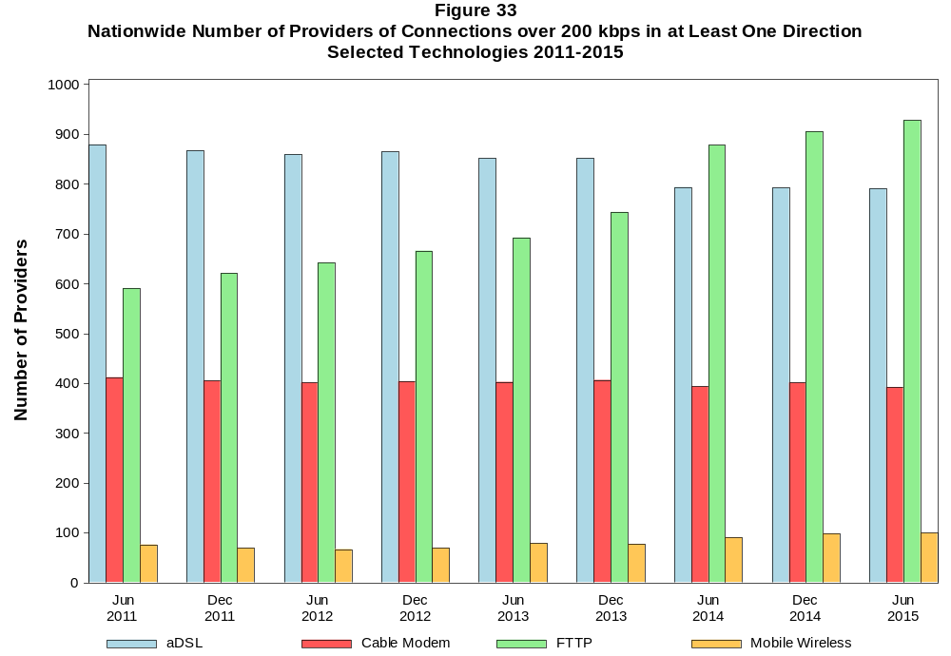

Figure 34
Residential Fixed Connections and Households by State as of June 30, 2015
(Connections and households, in thousands)

 |  | At least 200 kbps in  at least One Direction |  | At least 10 Mbps Down  and 1 Mbps Up |  | At least 25 Mbps Down  and 3 Mbps Up |  | At least 100 Mbps Down  and 10 Mbps Up
State | Households | Connections | Subscribership  Ratio | Connections | Subscribership  Ratio | Connections | Subscribership  Ratio | Connections | Subscribership  Ratio
Alabama | 1,842 | 1,224 | 0.66 | 819 | 0.44 | 431 | 0.23 | 25 | 0.01
Alaska | 252 | 200 | 0.80 | 133 | 0.53 | * | * | * | *
American Samoa | 10 | * | * | 0 | 0.00 | 0 | 0.00 | 0 | 0.00
Arizona | 2,387 | 1,909 | 0.80 | 1,281 | 0.54 | 1,033 | 0.43 | 291 | 0.12
Arkansas | 1,132 | 709 | 0.63 | 433 | 0.38 | 227 | 0.20 | 83 | 0.07
California | 12,617 | 10,569 | 0.84 | 8,222 | 0.65 | 5,726 | 0.45 | 1,955 | 0.15
Colorado | 1,998 | 1,731 | 0.87 | 1,091 | 0.55 | 1,028 | 0.51 | * | *
Connecticut | 1,356 | 1,104 | 0.81 | 929 | 0.69 | 743 | 0.55 | 204 | 0.15
Delaware | 339 | 308 | 0.91 | 275 | 0.81 | * | * | * | *
District of Columbia | 267 | 223 | 0.84 | 187 | 0.70 | * | * | * | *
Florida | 7,218 | 6,253 | 0.87 | 4,942 | 0.68 | 2,813 | 0.39 | 430 | 0.06
Georgia | 3,541 | 2,693 | 0.76 | 1,889 | 0.53 | 1,281 | 0.36 | 193 | 0.05
Guam | 42 | * | * | * | * | * | * | 0 | 0.00
Hawaii | 450 | 381 | 0.85 | 371 | 0.82 | * | * | * | *
Idaho | 585 | 437 | 0.75 | 204 | 0.35 | 148 | 0.25 | 6 | 0.01
Illinois | 4,779 | 3,598 | 0.75 | 2,680 | 0.56 | 1,869 | 0.39 | * | *
Indiana | 2,492 | 1,751 | 0.70 | 1,180 | 0.47 | 678 | 0.27 | 116 | 0.05
Iowa | 1,232 | 885 | 0.72 | 457 | 0.37 | 82 | 0.07 | 6 | 0.00
Kansas | 1,112 | 833 | 0.75 | 567 | 0.51 | 299 | 0.27 | 85 | 0.08
Kentucky | 1,702 | 1,168 | 0.69 | 705 | 0.41 | 206 | 0.12 | 16 | 0.01
Louisiana | 1,719 | 1,176 | 0.68 | 855 | 0.50 | 553 | 0.32 | 158 | 0.09
Maine | 553 | 454 | 0.82 | 303 | 0.55 | 90 | 0.16 | * | *
Maryland | 2,156 | 1,797 | 0.83 | 1,588 | 0.74 | 1,377 | 0.64 | * | *
Massachusetts | 2,538 | 2,222 | 0.88 | 1,967 | 0.77 | 1,826 | 0.72 | * | *
Michigan | 3,828 | 2,803 | 0.73 | 2,139 | 0.56 | 1,455 | 0.38 | * | *
Minnesota | 2,115 | 1,590 | 0.75 | 1,009 | 0.48 | 841 | 0.40 | 10 | 0.00
Mississippi | 1,093 | 604 | 0.55 | 371 | 0.34 | 209 | 0.19 | 31 | 0.03
Missouri | 2,361 | 1,672 | 0.71 | 1,106 | 0.47 | 616 | 0.26 | 150 | 0.06
Montana | 408 | 307 | 0.75 | 161 | 0.39 | * | * | * | *
Nebraska | 731 | 541 | 0.74 | 340 | 0.47 | 226 | 0.31 | 29 | 0.04

Figure 34 - Continued
Residential Fixed Connections and Households by State as of June 30, 2015
(Connections and households, in thousands)

 |  | At least 200 kbps in  at least One Direction |  | At least 10 Mbps Down  and 1 Mbps Up |  | At least 25 Mbps Down  and 3 Mbps Up |  | At least 100 Mbps Down  and 10 Mbps Up
State | Households | Connections | Subscribership  Ratio | Connections | Subscribership  Ratio | Connections | Subscribership  Ratio | Connections | Subscribership  Ratio
Nevada | 1,006 | 818 | 0.81 | 597 | 0.59 | 456 | 0.45 | * | *
New Hampshire | 520 | 459 | 0.88 | 365 | 0.70 | 287 | 0.55 | * | *
New Jersey | 3,188 | 2,840 | 0.89 | 2,583 | 0.81 | 2,440 | 0.77 | 549 | 0.17
New Mexico | 765 | 527 | 0.69 | 237 | 0.31 | 216 | 0.28 | 64 | 0.08
New York | 7,256 | 5,980 | 0.82 | 5,338 | 0.74 | 4,051 | 0.56 | 615 | 0.08
North Carolina | 3,743 | 2,802 | 0.75 | 1,957 | 0.52 | 798 | 0.21 | 100 | 0.03
North Dakota | 293 | 232 | 0.79 | 178 | 0.61 | 120 | 0.41 | 12 | 0.04
Northern Mariana Isl | 16 | * | * | 0 | 0.00 | 0 | 0.00 | 0 | 0.00
Ohio | 4,570 | 3,395 | 0.74 | 2,307 | 0.50 | 754 | 0.17 | 37 | 0.01
Oklahoma | 1,450 | 973 | 0.67 | 643 | 0.44 | 376 | 0.26 | 98 | 0.07
Oregon | 1,523 | 1,146 | 0.75 | 786 | 0.52 | 698 | 0.46 | * | *
Pennsylvania | 4,958 | 3,821 | 0.77 | 2,807 | 0.57 | 2,470 | 0.50 | * | *
Puerto Rico | 1,241 | 614 | 0.49 | * | * | 1 | 0.00 | * | *
Rhode Island | 410 | 339 | 0.83 | 323 | 0.79 | * | * | * | *
South Carolina | 1,796 | 1,311 | 0.73 | 964 | 0.54 | 423 | 0.24 | 16 | 0.01
South Dakota | 327 | 244 | 0.75 | 187 | 0.57 | 136 | 0.42 | * | *
Tennessee | 2,487 | 1,690 | 0.68 | 1,269 | 0.51 | 957 | 0.38 | 158 | 0.06
Texas | 9,014 | 6,743 | 0.75 | 4,986 | 0.55 | 2,649 | 0.29 | 1,149 | 0.13
Utah | 896 | 760 | 0.85 | 456 | 0.51 | 394 | 0.44 | 167 | 0.19
Vermont | 257 | 217 | 0.84 | 142 | 0.55 | 115 | 0.45 | 43 | 0.17
Virgin Islands | 43 | 24 | 0.54 | * | * | * | * | * | *
Virginia | 3,042 | 2,413 | 0.79 | 1,980 | 0.65 | 1,639 | 0.54 | 358 | 0.12
Washington | 2,645 | 2,166 | 0.82 | 1,562 | 0.59 | 1,461 | 0.55 | 628 | 0.24
West Virginia | 742 | 493 | 0.66 | 310 | 0.42 | 267 | 0.36 | * | *
Wisconsin | 2,293 | 1,698 | 0.74 | 1,179 | 0.51 | 579 | 0.25 | 4 | 0.00
Wyoming | 226 | 170 | 0.75 | 105 | 0.46 | * | * | # | 0.00
Total | 117,564 | 91,059 | 0.77 | 67,625 | 0.58 | 46,086 | 0.39 | 11,272 | 0.10

# = Rounds to Zero; * = Data withheld to maintain firm confidentiality.
Note: Figures may not sum to totals due to rounding.
Sources: FCC Form 477 (Connections); 2010-2014 ACS 5-year estimates; Census 2010.

Figure 35
Connections by Type of End User by State as of June 30, 2015
(Connections over 200 kbps in at least one direction, in thousands)

 | Connections |  | Percentages
State | Residential | Business | Residential | Business | Total
Alabama | 4,182 | 531 | 88.7 | 11.3 | 4,713
Alaska | 727 | 115 | 86.4 | 13.6 | 841
American Samoa | * | * | * | * | *
Arizona | 5,739 | 907 | 86.3 | 13.7 | 6,647
Arkansas | 2,529 | 345 | 88.0 | 12.0 | 2,874
California | 36,846 | 6,642 | 84.7 | 15.3 | 43,487
Colorado | 5,170 | 869 | 85.6 | 14.4 | 6,038
Connecticut | 3,498 | 614 | 85.1 | 14.9 | 4,112
Delaware | 909 | 152 | 85.7 | 14.3 | 1,061
District of Columbia | 794 | 446 | 64.0 | 36.0 | 1,240
Florida | 17,357 | 3,139 | 84.7 | 15.3 | 20,497
Georgia | 8,753 | 1,450 | 85.8 | 14.2 | 10,202
Guam | 100 | 21 | 82.6 | 17.4 | 121
Hawaii | 1,417 | 185 | 88.5 | 11.5 | 1,601
Idaho | 1,405 | 223 | 86.3 | 13.7 | 1,628
Illinois | 11,878 | 2,118 | 84.9 | 15.1 | 13,996
Indiana | 5,673 | 807 | 87.5 | 12.5 | 6,480
Iowa | 2,716 | 444 | 85.9 | 14.1 | 3,160
Kansas | 2,480 | 450 | 84.6 | 15.4 | 2,930
Kentucky | 4,843 | 533 | 90.1 | 9.9 | 5,376
Louisiana | 4,338 | 591 | 88.0 | 12.0 | 4,930
Maine | 1,159 | 184 | 86.3 | 13.7 | 1,343
Maryland | 5,636 | 972 | 85.3 | 14.7 | 6,607
Massachusetts | 6,541 | 1,193 | 84.6 | 15.4 | 7,734
Michigan | 8,244 | 1,645 | 83.4 | 16.6 | 9,889
Minnesota | 4,972 | 913 | 84.5 | 15.5 | 5,885
Mississippi | 2,514 | 266 | 90.4 | 9.6 | 2,780
Missouri | 5,333 | 945 | 84.9 | 15.1 | 6,279
Montana | 893 | 121 | 88.1 | 11.9 | 1,013
Nebraska | 1,571 | 322 | 83.0 | 17.0 | 1,894
Nevada | 2,576 | 376 | 87.2 | 12.8 | 2,952
New Hampshire | 1,250 | 198 | 86.4 | 13.6 | 1,448
New Jersey | 9,056 | 1,665 | 84.5 | 15.5 | 10,721
New Mexico | 1,696 | 243 | 87.5 | 12.5 | 1,939
New York | 18,429 | 3,339 | 84.7 | 15.3 | 21,767
North Carolina | 8,478 | 1,431 | 85.6 | 14.4 | 9,909
North Dakota | 701 | 125 | 84.9 | 15.1 | 826
Northern Mariana Isl | * | * | * | * | *
Ohio | 10,363 | 1,684 | 86.0 | 14.0 | 12,048
Oklahoma | 3,427 | 526 | 86.7 | 13.3 | 3,954
Oregon | 3,628 | 610 | 85.6 | 14.4 | 4,238
Pennsylvania | 11,465 | 1,825 | 86.3 | 13.7 | 13,290
Puerto Rico | 2,926 | 226 | 92.8 | 7.2 | 3,152
Rhode Island | 968 | 160 | 85.8 | 14.2 | 1,128
South Carolina | 4,087 | 564 | 87.9 | 12.1 | 4,651
South Dakota | 732 | 94 | 88.6 | 11.4 | 827
Tennessee | 5,610 | 890 | 86.3 | 13.7 | 6,500
Texas | 23,772 | 4,348 | 84.5 | 15.5 | 28,120
Utah | 2,526 | 442 | 85.1 | 14.9 | 2,968
Vermont | 571 | 97 | 85.4 | 14.6 | 668
Virgin Islands | 97 | 16 | 85.8 | 14.2 | 113
Virginia | 7,484 | 1,426 | 84.0 | 16.0 | 8,910
Washington | 6,809 | 1,158 | 85.5 | 14.5 | 7,967
West Virginia | 1,504 | 180 | 89.3 | 10.7 | 1,685
Wisconsin | 4,939 | 881 | 84.9 | 15.1 | 5,820
Wyoming | 559 | 77 | 88.0 | 12.0 | 636
Total | 291,919 | 49,729 | 85.4 | 14.6 | 341,648

# = Rounds to Zero.
* = Data withheld to maintain firm confidentiality.
Figures may not sum to totals due to rounding.
Source: FCC Form 477.

Figure 36
Connections by Technology by State as of June 30, 2015
(Connections over 200 kbps in at least one direction, in thousands)

State | ADSL | SDSL | Other  Wireline¹ | Cable  Modem | Fiber | Satellite | Fixed  Wireless | Mobile  Wireless | Total
Alabama | 529 | 3 | * | 702 | 26 | * | 4 | 3,373 | 4,713
Alaska | 78 | 1 | 2 | * | 3 | * | 7 | 602 | 841
American Samoa | 0 | 0 | 0 | * | * | 0 | * | * | *
Arizona | 635 | # | * | 1,293 | 56 | * | 30 | 4,589 | 6,647
Arkansas | 347 | # | * | 349 | 14 | * | 5 | 2,101 | 2,874
California | 3,931 | 13 | * | 6,450 | 915 | * | 58 | 31,876 | 43,487
Colorado | 632 | # | * | 1,038 | 108 | * | 56 | 4,148 | 6,038
Connecticut | 28 | * | 5 | 915 | * | * | * | 2,911 | 4,112
Delaware | * | # | 3 | * | * | * | 0 | 727 | 1,061
District of Columbia | * | * | 7 | * | 41 | * | * | 980 | 1,240
Florida | 1,867 | 1 | * | 4,245 | 581 | * | 11 | 13,664 | 20,497
Georgia | 1,150 | 1 | * | 1,632 | 76 | * | 1 | 7,244 | 10,202
Guam | * | 0 | * | * | * | 0 | 0 | 82 | 121
Hawaii | * | 2 | 1 | * | 18 | 4 | 4 | 1,188 | 1,601
Idaho | 194 | # | * | 202 | 29 | * | 37 | 1,150 | 1,628
Illinois | 1,281 | 3 | * | 2,452 | 43 | * | 63 | 10,077 | 13,996
Indiana | 666 | 1 | * | 1,040 | 87 | * | 42 | 4,580 | 6,480
Iowa | 345 | 1 | * | 444 | 112 | * | 32 | 2,193 | 3,160
Kansas | 282 | # | * | 475 | 92 | * | 35 | 2,019 | 2,930
Kentucky | 482 | 1 | * | 655 | 59 | * | 17 | 4,101 | 5,376
Louisiana | 438 | # | * | 720 | 57 | * | 6 | 3,642 | 4,930
Maine | 135 | 2 | * | 342 | 7 | * | 4 | 839 | 1,343
Maryland | * | 1 | 16 | 974 | * | * | 2 | 4,653 | 6,607
Massachusetts | * | 1 | 22 | 1,694 | * | * | 1 | 5,293 | 7,734
Michigan | 874 | 4 | * | 1,992 | 14 | * | 43 | 6,844 | 9,889
Minnesota | 561 | 4 | * | 990 | 106 | * | 27 | 4,153 | 5,885
Mississippi | 317 | * | 2 | 290 | 6 | * | 2 | 2,107 | 2,780
Missouri | 815 | # | * | 787 | 97 | * | 33 | 4,459 | 6,279
Montana | 117 | 1 | * | 173 | 16 | * | 21 | 670 | 1,013
Nebraska | 164 | # | * | 360 | 38 | * | 21 | 1,299 | 1,894

Figure 36 - Continued
Connections by Technology by State as of June 30, 2015
(Connections over 200 kbps in at least one direction, in thousands)

State | ADSL | SDSL | Other  Wireline¹ | Cable  Modem | Fiber | Satellite | Fixed  Wireless | Mobile  Wireless | Total
Nevada | 250 | # | * | 608 | 8 | * | 13 | 2,059 | 2,952
New Hampshire | 88 | # | * | 394 | 19 | * | # | 933 | 1,448
New Jersey | 266 | 1 | 29 | 1,949 | * | * | # | 7,584 | 10,721
New Mexico | 289 | # | * | 238 | 15 | * | 19 | 1,359 | 1,939
New York | 584 | 6 | 39 | 4,506 | * | * | 4 | 15,136 | 21,767
North Carolina | 1,014 | # | * | 1,899 | 76 | * | 4 | 6,837 | 9,909
North Dakota | 63 | 1 | 2 | 131 | 58 | 4 | 6 | 563 | 826
Northern Mariana Isl | * | 0 | 0 | * | 0 | 0 | 0 | * | *
Ohio | 1,144 | 1 | * | 2,316 | 109 | * | 39 | 8,367 | 12,048
Oklahoma | 392 | # | * | 547 | 27 | * | 35 | 2,885 | 3,954
Oregon | 317 | 1 | * | 831 | 52 | * | 18 | 2,983 | 4,238
Pennsylvania | 798 | 2 | 24 | 2,488 | * | * | 4 | 9,109 | 13,290
Puerto Rico | * | 0 | * | * | 6 | * | 2 | 2,481 | 3,152
Rhode Island | * | # | 2 | * | * | * | * | 757 | 1,128
South Carolina | 473 | # | * | 837 | 66 | * | 2 | 3,223 | 4,651
South Dakota | 58 | * | # | 153 | 42 | * | 11 | 557 | 827
Tennessee | 568 | 4 | * | 1,055 | 138 | * | 9 | 4,644 | 6,500
Texas | 2,930 | 3 | * | 3,313 | 653 | * | 148 | 20,785 | 28,120
Utah | 262 | 1 | * | 403 | 92 | * | 60 | 2,142 | 2,968
Vermont | 94 | # | * | 128 | 15 | * | 1 | 421 | 668
Virgin Islands | * | 0 | * | * | * | * | * | 81 | 113
Virginia | 389 | 1 | * | 1,339 | 793 | * | 14 | 6,262 | 8,910
Washington | 530 | 1 | * | 1,645 | 89 | * | 20 | 5,618 | 7,967
West Virginia | * | * | 1 | 362 | 8 | * | 2 | 1,150 | 1,685
Wisconsin | 647 | 7 | * | 1,051 | 54 | * | 33 | 3,975 | 5,820
Wyoming | 54 | * | 5 | 101 | 6 | * | 16 | 443 | 636
Total | 28,194 | 76 | 701 | 57,850 | 9,768 | 2,058 | 1,040 | 241,962 | 341,648

¹ Power Line and Other are summarized with Other Wireline to maintain firm confidentiality. See Technical Notes at the end of the report for a description of Form 477 technology categories and
other reporting requirements.
# = Rounds to Zero.
* = Data withheld to maintain firm confidentiality.
Figures may not sum to totals due to rounding.
Source: FCC Form 477.

Figure 37
Percentage of Fixed Connections by Downstream Speed by State as of June 30, 2015

 | Over 200 kbps Upstream and
State | % over 200 kbps  Downstream | % at least 3 Mbps  Downstream | % at least 10 Mbps  Downstream | % at least 25 Mbps  Downstream | % at least 100 Mbps  Downstream
Alabama | 98.5 | 90.0 | 68.9 | 37.6 | 2.3
Alaska | 95.8 | 84.9 | 63.0 | 19.9 | 8.1
American Samoa | * | * | * | * | *
Arizona | 99.3 | 94.0 | 79.4 | 52.0 | 14.5
Arkansas | 98.8 | 89.0 | 63.8 | 32.4 | 13.8
California | 99.5 | 94.9 | 75.4 | 51.5 | 17.4
Colorado | 99.7 | 92.3 | 78.0 | 56.8 | 24.0
Connecticut | 99.9 | 97.5 | 83.2 | 65.6 | 17.5
Delaware | 99.7 | 97.1 | 88.1 | 75.5 | 21.7
District of Columbia | 99.6 | 94.8 | 79.9 | 72.9 | 25.6
Florida | 99.3 | 94.7 | 81.5 | 52.7 | 6.8
Georgia | 98.6 | 92.3 | 70.4 | 46.5 | 7.0
Guam | * | * | * | * | *
Hawaii | 99.9 | 98.0 | 94.9 | 34.6 | 8.0
Idaho | 99.1 | 89.6 | 62.5 | 33.1 | 1.3
Illinois | 99.5 | 94.9 | 73.8 | 50.8 | 11.7
Indiana | 99.1 | 92.4 | 68.4 | 39.5 | 6.4
Iowa | 99.0 | 88.0 | 59.9 | 20.3 | 0.8
Kansas | 99.5 | 90.9 | 68.1 | 34.6 | 11.3
Kentucky | 97.9 | 87.7 | 60.3 | 17.2 | 1.5
Louisiana | 98.6 | 91.6 | 71.8 | 45.1 | 12.8
Maine | 98.2 | 89.4 | 64.8 | 18.9 | 1.7
Maryland | 99.6 | 96.3 | 86.3 | 74.0 | 19.1
Massachusetts | 99.7 | 96.7 | 86.9 | 78.6 | 25.0
Michigan | 99.0 | 94.6 | 75.5 | 50.3 | 6.0
Minnesota | 99.5 | 91.3 | 73.3 | 52.3 | 1.0
Mississippi | 98.0 | 87.8 | 61.6 | 33.1 | 4.9
Missouri | 98.9 | 90.3 | 69.8 | 37.3 | 27.0
Montana | 99.0 | 82.9 | 57.9 | 47.1 | 0.7
Nebraska | 99.2 | 92.1 | 66.8 | 39.8 | 5.3

Figure 37 - Continued
Percentage of Fixed Connections by Downstream Speed by State as of June 30, 2015

 | Over 200 kbps Upstream and
State | % over 200 kbps  Downstream | % at least 3 Mbps  Downstream | % at least 10 Mbps  Downstream | % at least 25 Mbps  Downstream | % at least 100 Mbps  Downstream
Nevada | 99.7 | 95.9 | 81.3 | 54.3 | 9.0
New Hampshire | 98.6 | 94.1 | 77.8 | 58.6 | 23.6
New Jersey | 99.6 | 97.0 | 89.9 | 83.5 | 18.4
New Mexico | 99.2 | 87.2 | 61.9 | 38.8 | 11.4
New York | 99.3 | 95.8 | 86.9 | 65.5 | 10.1
North Carolina | 99.1 | 90.8 | 73.5 | 27.6 | 3.4
North Dakota | 99.8 | 94.5 | 77.6 | 52.7 | 5.6
Northern Mariana Isl | * | * | * | * | *
Ohio | 99.5 | 90.3 | 68.1 | 21.5 | 1.2
Oklahoma | 99.3 | 93.3 | 65.3 | 36.8 | 9.5
Oregon | 99.4 | 91.5 | 76.3 | 59.3 | 21.6
Pennsylvania | 99.5 | 93.3 | 74.8 | 62.8 | 18.2
Puerto Rico | 99.9 | 68.3 | 30.3 | 3.6 | 0.2
Rhode Island | 99.5 | 97.9 | 92.3 | 76.1 | 7.6
South Carolina | 99.0 | 91.6 | 73.5 | 31.9 | 1.3
South Dakota | 99.4 | 93.9 | 78.1 | 55.9 | 5.9
Tennessee | 98.7 | 93.1 | 75.2 | 54.4 | 9.2
Texas | 99.5 | 93.7 | 73.0 | 37.8 | 16.4
Utah | 99.7 | 93.8 | 73.3 | 49.9 | 20.8
Vermont | 97.6 | 90.8 | 63.9 | 49.0 | 18.1
Virgin Islands | 99.9 | 82.8 | 13.5 | * | *
Virginia | 99.3 | 94.7 | 81.0 | 64.6 | 14.3
Washington | 99.4 | 93.3 | 78.8 | 65.2 | 27.7
West Virginia | 96.6 | 89.6 | 60.7 | 51.0 | 36.0
Wisconsin | 99.0 | 89.5 | 71.8 | 33.4 | 0.6
Wyoming | 99.2 | 86.5 | 67.2 | 49.3 | 0.4
Total | 99.3 | 93.2 | 75.5 | 49.8 | 12.4

Figure 38
Providers of Connections by Technology by State as of June 30, 2015
(Connections over 200 kbps in at least one direction, in thousands)

State | ADSL | SDSL | Other  Wireline¹ | Cable  Modem | Fiber | Satellite | Fixed  Wireless | Mobile  Wireless | Total
Alabama | 28 | 10 | * | 21 | 35 | * | 21 | 6 | 84
Alaska | 14 | 5 | 9 | * | 6 | * | 10 | 7 | 31
American Samoa | 0 | 0 | 0 | * | * | 0 | * | * | *
Arizona | 25 | 6 | * | 16 | 27 | * | 36 | 7 | 94
Arkansas | 22 | 4 | * | 18 | 26 | * | 16 | 4 | 66
California | 39 | 12 | * | 30 | 48 | * | 76 | 6 | 162
Colorado | 37 | 9 | * | 16 | 45 | * | 49 | 10 | 128
Connecticut | 11 | * | 18 | 11 | * | * | * | 4 | 43
Delaware | * | 4 | 13 | * | * | * | 0 | 4 | 27
District of Columbia | * | * | 19 | * | 20 | * | * | 4 | 39
Florida | 30 | 11 | * | 26 | 46 | * | 32 | 5 | 112
Georgia | 30 | 10 | * | 33 | 59 | * | 22 | 4 | 123
Guam | * | 0 | * | * | * | 0 | 0 | 4 | 4
Hawaii | * | 6 | 7 | * | 9 | 4 | 4 | 5 | 22
Idaho | 23 | 4 | * | 16 | 27 | * | 29 | 10 | 70
Illinois | 59 | 13 | * | 19 | 63 | * | 71 | 9 | 172
Indiana | 39 | 11 | * | 13 | 49 | * | 53 | 5 | 111
Iowa | 110 | 19 | * | 44 | 115 | * | 85 | 31 | 220
Kansas | 33 | 13 | * | 28 | 50 | * | 45 | 9 | 107
Kentucky | 24 | 8 | * | 28 | 40 | * | 27 | 7 | 97
Louisiana | 18 | 5 | * | 15 | 26 | * | 16 | 5 | 65
Maine | 17 | 10 | * | 7 | 18 | * | 6 | 5 | 38
Maryland | * | 9 | 31 | 15 | * | * | 17 | 6 | 76
Massachusetts | * | 8 | 29 | 11 | * | * | 13 | 4 | 65
Michigan | 37 | 13 | * | 23 | 41 | * | 37 | 6 | 111
Minnesota | 52 | 16 | * | 22 | 66 | * | 47 | 6 | 126
Mississippi | 16 | * | 15 | 15 | 18 | * | 18 | 5 | 61
Missouri | 39 | 12 | * | 21 | 46 | * | 64 | 8 | 142
Montana | 21 | 6 | * | 9 | 25 | * | 24 | 5 | 56
Nebraska | 33 | 5 | * | 21 | 41 | * | 34 | 8 | 87

Figure 38 - Continued
Providers of Connections by Technology by State as of June 30, 2015
(Connections over 200 kbps in at least one direction, in thousands)

State | ADSL | SDSL | Other  Wireline¹ | Cable  Modem | Fiber | Satellite | Fixed  Wireless | Mobile  Wireless | Total
Nevada | 19 | 8 | * | 9 | 23 | * | 14 | 7 | 66
New Hampshire | 14 | 8 | * | 7 | 20 | * | 4 | 5 | 42
New Jersey | 19 | 7 | 33 | 10 | * | * | 9 | 4 | 61
New Mexico | 23 | 7 | * | 10 | 20 | * | 24 | 9 | 63
New York | 40 | 10 | 38 | 22 | * | * | 23 | 4 | 103
North Carolina | 27 | 8 | * | 28 | 41 | * | 19 | 7 | 90
North Dakota | 27 | 10 | 14 | 6 | 25 | 4 | 17 | 7 | 53
Northern Mariana Isl | * | 0 | 0 | * | 0 | 0 | 0 | * | *
Ohio | 42 | 10 | * | 32 | 48 | * | 43 | 5 | 135
Oklahoma | 36 | 6 | * | 11 | 35 | * | 34 | 11 | 95
Oregon | 41 | 11 | * | 14 | 44 | * | 35 | 6 | 98
Pennsylvania | 37 | 10 | 38 | 30 | * | * | 23 | 8 | 113
Puerto Rico | * | 0 | * | * | 5 | * | 5 | 5 | 16
Rhode Island | * | 5 | 12 | * | * | * | * | 4 | 25
South Carolina | 17 | 4 | * | 16 | 25 | * | 8 | 6 | 49
South Dakota | 24 | * | 10 | 6 | 29 | * | 23 | 8 | 65
Tennessee | 26 | 9 | * | 23 | 37 | * | 23 | 7 | 90
Texas | 63 | 20 | * | 38 | 76 | * | 112 | 11 | 226
Utah | 20 | 9 | * | 11 | 23 | * | 28 | 8 | 75
Vermont | 11 | 5 | * | 7 | 17 | * | 4 | 5 | 36
Virgin Islands | * | 0 | * | * | * | * | * | 4 | 9
Virginia | 27 | 11 | * | 20 | 39 | * | 33 | 7 | 103
Washington | 30 | 11 | * | 24 | 41 | * | 49 | 6 | 110
West Virginia | * | * | 14 | 16 | 13 | * | 8 | 7 | 50
Wisconsin | 46 | 12 | * | 23 | 57 | * | 44 | 10 | 122
Wyoming | 16 | * | 13 | 5 | 15 | * | 24 | 8 | 48
Total | 791 | 179 | 241 | 392 | 928 | 11 | 940 | 100 | 1,870

¹ Power Line and Other are summarized with Other Wireline. See Technical Notes at the end of the report for a description of Form 477 technology categories and other reporting requirements.
# = Rounds to Zero.
* = Data withheld to maintain firm confidentiality.
Figures may not sum to totals due to rounding.
Source: FCC Form 477.

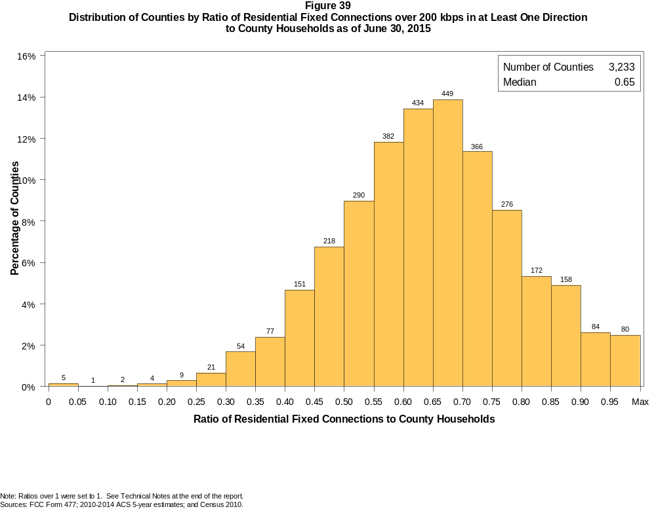

Figure 40
Distribution of Counties by Ratio of Residential Fixed Connections over 200 kbps in at Least One Direction
to County Households by Technology as of June 30, 2015

 | Ratio of Residential Fixed Connections to County Households
Technology | Zero | Greater than 0 and no more than 5% | Greater than 5 and no more than 10% | Greater than 10 and no more than 20% | Greater than 20 and no more than 30% | Greater than 30 and no more than 40% | Greater than 40 and no more than 50% | Greater than 50 and no more than 60% | Greater than 60 and no more than 80% | Greater than 80 and no more than 100% | 100% or more
aDSL | 0.9 | 4.5 | 6.7 | 27.4 | 29.2 | 18.3 | 8.3 | 2.9 | 1.5 | 0.2 | 0.1
sDSL | 85.9 | 13.8 | 0.2 | 0.0 | 0.1 | 0.0 | 0.0 | 0.0 | 0.0 | 0.0 | 0.0
Other Wireline | 90.6 | 9.0 | 0.2 | 0.2 | 0.0 | 0.0 | 0.0 | 0.0 | 0.0 | 0.0 | 0.0
Cable Modem | 11.5 | 7.8 | 6.8 | 16.1 | 15.6 | 14.8 | 12.4 | 9.3 | 4.9 | 0.5 | 0.2
FTTP | 39.2 | 38.4 | 6.6 | 6.8 | 3.2 | 2.2 | 1.6 | 0.9 | 1.0 | 0.1 | 0.0
Satellite | 0.9 | 62.7 | 24.4 | 10.5 | 1.4 | 0.1 | 0.0 | 0.0 | 0.0 | 0.0 | 0.0
Fixed Wireless | 30.4 | 51.7 | 10.4 | 5.6 | 1.2 | 0.4 | 0.2 | 0.0 | 0.0 | 0.0 | 0.0
Total | 0.1 | 0.0 | 0.0 | 0.2 | 0.9 | 4.1 | 11.4 | 20.8 | 47.2 | 13.6 | 1.6

¹ Power Line and Other are summarized with Other Wireline. See Technical Notes at the end of the report for a description of Form 477 technology categories and other reporting requirements.
Note: Figures may not sum to totals due to rounding.
Sources: FCC Form 477; 2010-2014 ACS 5-year estimates; and Census 2010.

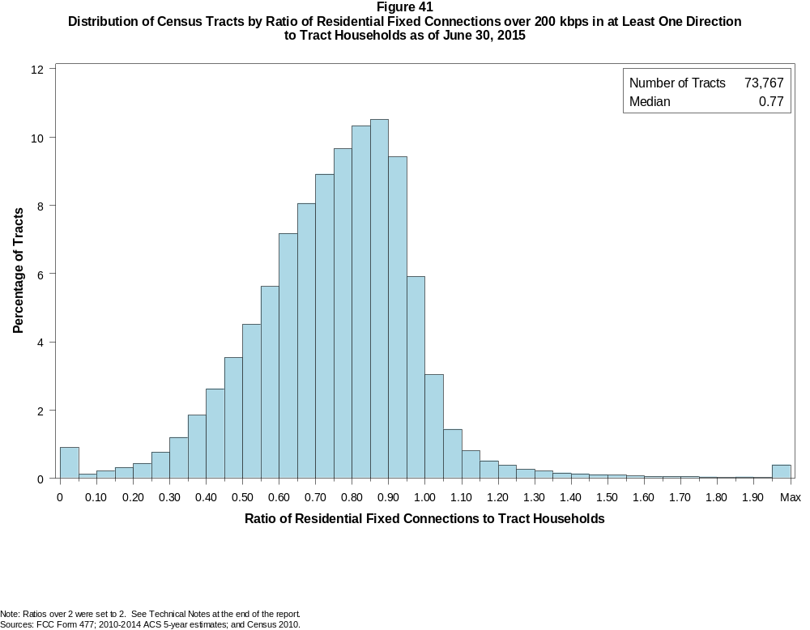

Figure 42
Distribution of Census Tracts by Ratio of Residential Fixed Connections over 200 kbps in at Least One Direction
to Tract Households by Technology as of June 30, 2015

 | Ratio of Residential Fixed Connections to Tract Households
Technology | Zero | Greater than 0 and no more than 5% | Greater than 5 and no more than 10% | Greater than 10 and no more than 20% | Greater than 20 and no more than 30% | Greater than 30 and no more than 40% | Greater than 40 and no more than 50% | Greater than 50 and no more than 60% | Greater than 60 and no more than 80% | Greater than 80 and no more than 100% | 100% or more
aDSL | 1.6 | 15.1 | 11.7 | 24.7 | 20.9 | 14.4 | 7.2 | 2.7 | 1.4 | 0.2 | 0.2
sDSL | 97.7 | 2.3 | 0.0 | 0.0 | 0.0 | 0.0 | 0.0 | 0.0 | 0.0 | 0.0 | 0.0
Other Wireline | 98.8 | 1.0 | 0.1 | 0.1 | 0.0 | 0.0 | 0.0 | 0.0 | 0.0 | 0.0 | 0.0
Cable Modem | 4.9 | 3.1 | 2.0 | 5.2 | 10.2 | 16.0 | 18.8 | 16.8 | 17.9 | 3.9 | 1.2
FTTP | 62.0 | 15.5 | 3.1 | 4.4 | 3.3 | 3.6 | 3.6 | 2.4 | 1.7 | 0.2 | 0.1
Satellite | 25.0 | 64.6 | 5.6 | 3.5 | 0.9 | 0.2 | 0.1 | 0.0 | 0.0 | 0.0 | 0.0
Fixed Wireless | 76.9 | 18.1 | 2.3 | 1.8 | 0.6 | 0.2 | 0.1 | 0.0 | 0.0 | 0.0 | 0.0
Total | 0.8 | 0.1 | 0.1 | 0.5 | 1.2 | 3.1 | 6.2 | 10.1 | 33.8 | 36.2 | 7.9

¹ Power Line and Other are summarized with Other Wireline. See Technical Notes at the end of the report for a description of Form 477 technology categories and other reporting requirements.
Note: Figures may not sum to totals due to rounding.
Sources: FCC Form 477; 2010-2014 ACS 5-year estimates; and Census 2010.

Figure 43
Percentage of Developed Census Blocks with Residential Fixed Service by Technology as of June 30, 2015
(Internet Access Service over 200 kbps in at least one direction)

 | Number of Providers
Technology | Zero | One | Two | Three | Four | Five | Six | Seven or More
aDSL | 28.5 | 68.3 | 2.8 | 0.3 | 0.0 | 0.0 | 0.0 | 0.0
sDSL | 98.9 | 1.1 | 0.0 | 0.0 | 0.0 | 0.0 | 0.0 | 0.0
Other Wireline¹ | 97.1 | 2.9 | 0.0 | 0.0 | 0.0 | 0.0 | 0.0 | 0.0
Cable Modem | 33.8 | 62.2 | 3.7 | 0.2 | 0.0 | 0.0 | 0.0 | 0.0
FTTP | 85.2 | 14.5 | 0.3 | 0.0 | 0.0 | 0.0 | 0.0 | 0.0
Satellite | 0.1 | 0.9 | 58.6 | 40.4 | 0.0 | 0.0 | 0.0 | 0.0
Fixed Wireless | 62.2 | 24.4 | 9.3 | 3.5 | 0.6 | 0.0 | 0.0 | 0.0
aDSL and/or Cable Modem and/or FTTP | 15.4 | 24.6 | 52.2 | 6.9 | 0.7 | 0.1 | 0.0 | 0.0
Any Technology | 0.0 | 0.2 | 4.4 | 14.9 | 34.5 | 28.6 | 11.8 | 5.6

¹ Power Line and Other are summarized with Other Wireline. See Technical Notes at the end of the report for a description of Form 477 technology categories and other reporting requirements.
Note: Figures may not sum to totals due to rounding. The number of providers in a census block does not necessarily reflect the number of choices available to a particular household, and does not
purport to measure competition. Providers may list a census block on Form 477 if service can be provided to at least one location in the block. Developed census blocks are those with housing units
based on the 2010 census.
Sources: FCC Form 477 and Census 2010.

Figure 44
Distribution of Counties by Ratio of Residential Fixed Connections to County Households by State as of June 30, 2015
(Connections over 200 kbps in at least one direction)

 |  | Ratio of Residential Fixed Connections over 200 kbps in at Least One Direction to County Households
State | Counties | Zero | Greater than 0 and no more than 5% | Greater than 5 and no more than 10% | Greater than 10 and no more than 20% | Greater than 20 and no more than 30% | Greater than 30 and no more than 40% | Greater than 40 and no more than 50% | Greater than 50 and no more than 60% | Greater than 60 and no more than 80% | Greater than 80 and no more than 100% | 100% or more
Alabama | 67 | 0 | 0 | 0 | 0 | 2 | 2 | 20 | 22 | 17 | 4 | 0
Alaska | 29 | 0 | 0 | 0 | 0 | 2 | 2 | 4 | 3 | 11 | 6 | 1
American Samoa | 5 | 3 | 0 | 1 | 1 | 0 | 0 | 0 | 0 | 0 | 0 | 0
Arizona | 15 | 0 | 0 | 0 | 0 | 0 | 1 | 1 | 1 | 10 | 2 | 0
Arkansas | 75 | 0 | 0 | 0 | 0 | 0 | 7 | 31 | 21 | 15 | 1 | 0
California | 58 | 0 | 0 | 0 | 0 | 0 | 1 | 0 | 2 | 31 | 23 | 1
Colorado | 64 | 0 | 0 | 0 | 0 | 0 | 1 | 4 | 6 | 25 | 17 | 11
Connecticut | 8 | 0 | 0 | 0 | 0 | 0 | 0 | 0 | 0 | 3 | 5 | 0
Delaware | 3 | 0 | 0 | 0 | 0 | 0 | 0 | 0 | 0 | 0 | 2 | 1
District of Columbia | 1 | 0 | 0 | 0 | 0 | 0 | 0 | 0 | 0 | 0 | 1 | 0
Florida | 67 | 0 | 0 | 0 | 0 | 0 | 0 | 2 | 14 | 13 | 32 | 6
Georgia | 159 | 0 | 0 | 0 | 1 | 3 | 12 | 31 | 38 | 45 | 26 | 3
Guam | 1 | 0 | 0 | 0 | 0 | 0 | 0 | 0 | 0 | 0 | 1 | 0
Hawaii | 5 | 0 | 1 | 0 | 0 | 0 | 0 | 0 | 0 | 1 | 3 | 0
Idaho | 44 | 0 | 0 | 0 | 0 | 0 | 0 | 4 | 11 | 23 | 4 | 2
Illinois | 102 | 0 | 0 | 0 | 1 | 2 | 3 | 11 | 26 | 50 | 9 | 0
Indiana | 92 | 0 | 0 | 0 | 0 | 0 | 0 | 6 | 22 | 57 | 7 | 0
Iowa | 99 | 0 | 0 | 0 | 0 | 0 | 0 | 0 | 18 | 77 | 3 | 1
Kansas | 105 | 0 | 0 | 0 | 0 | 0 | 0 | 6 | 20 | 70 | 9 | 0
Kentucky | 120 | 0 | 0 | 0 | 0 | 1 | 4 | 15 | 39 | 58 | 3 | 0
Louisiana | 64 | 0 | 0 | 0 | 0 | 1 | 7 | 12 | 13 | 28 | 3 | 0
Maine | 16 | 0 | 0 | 0 | 0 | 0 | 0 | 0 | 1 | 7 | 8 | 0
Maryland | 24 | 0 | 0 | 0 | 0 | 0 | 0 | 1 | 2 | 11 | 9 | 1
Massachusetts | 14 | 0 | 0 | 0 | 0 | 0 | 0 | 0 | 0 | 3 | 8 | 3
Michigan | 83 | 0 | 0 | 0 | 0 | 0 | 1 | 5 | 20 | 46 | 10 | 1
Minnesota | 87 | 0 | 0 | 0 | 0 | 0 | 5 | 6 | 8 | 57 | 11 | 0
Mississippi | 82 | 0 | 0 | 0 | 2 | 7 | 26 | 28 | 8 | 10 | 1 | 0
Missouri | 115 | 0 | 0 | 0 | 0 | 1 | 5 | 18 | 33 | 51 | 7 | 0
Montana | 56 | 0 | 0 | 0 | 0 | 0 | 1 | 0 | 9 | 37 | 9 | 0
Nebraska | 93 | 0 | 0 | 0 | 0 | 0 | 2 | 14 | 27 | 48 | 2 | 0

Figure 44 - Continued
Distribution of Counties by Ratio of Residential Fixed Connections to County Households by State as of June 30, 2015
(Connections over 200 kbps in at least one direction)

 |  | Ratio of Residential Fixed Connections over 200 kbps in at Least One Direction to County Households
State | Counties | Zero | Greater than 0 and no more than 5% | Greater than 5 and no more than 10% | Greater than 10 and no more than 20% | Greater than 20 and no more than 30% | Greater than 30 and no more than 40% | Greater than 40 and no more than 50% | Greater than 50 and no more than 60% | Greater than 60 and no more than 80% | Greater than 80 and no more than 100% | 100% or more
Nevada | 17 | 0 | 0 | 0 | 0 | 0 | 2 | 0 | 5 | 7 | 3 | 0
New Hampshire | 10 | 0 | 0 | 0 | 0 | 0 | 0 | 0 | 0 | 1 | 9 | 0
New Jersey | 21 | 0 | 0 | 0 | 0 | 0 | 0 | 0 | 0 | 3 | 17 | 1
New Mexico | 33 | 0 | 0 | 0 | 0 | 0 | 0 | 5 | 7 | 19 | 2 | 0
New York | 62 | 0 | 0 | 0 | 0 | 0 | 0 | 0 | 5 | 39 | 16 | 2
North Carolina | 100 | 0 | 0 | 0 | 0 | 0 | 0 | 8 | 21 | 53 | 15 | 3
North Dakota | 53 | 0 | 0 | 0 | 0 | 0 | 0 | 1 | 5 | 35 | 12 | 0
Northern Mariana Isl | 4 | 1 | 0 | 0 | 0 | 0 | 1 | 2 | 0 | 0 | 0 | 0
Ohio | 88 | 0 | 0 | 0 | 0 | 0 | 1 | 2 | 15 | 62 | 8 | 0
Oklahoma | 77 | 0 | 0 | 0 | 0 | 1 | 7 | 18 | 21 | 24 | 5 | 1
Oregon | 36 | 0 | 0 | 0 | 0 | 0 | 0 | 1 | 5 | 22 | 7 | 1
Pennsylvania | 67 | 0 | 0 | 0 | 0 | 0 | 0 | 0 | 7 | 46 | 13 | 1
Puerto Rico | 78 | 0 | 0 | 0 | 0 | 7 | 13 | 29 | 25 | 4 | 0 | 0
Rhode Island | 5 | 0 | 0 | 0 | 0 | 0 | 0 | 0 | 0 | 1 | 4 | 0
South Carolina | 46 | 0 | 0 | 0 | 0 | 0 | 4 | 9 | 9 | 19 | 4 | 1
South Dakota | 66 | 0 | 0 | 0 | 0 | 0 | 1 | 1 | 15 | 39 | 8 | 2
Tennessee | 95 | 0 | 0 | 0 | 0 | 1 | 4 | 17 | 39 | 30 | 4 | 0
Texas | 254 | 0 | 0 | 0 | 0 | 0 | 6 | 35 | 76 | 115 | 21 | 1
Utah | 29 | 0 | 0 | 0 | 0 | 0 | 0 | 0 | 4 | 10 | 12 | 3
Vermont | 14 | 0 | 0 | 0 | 0 | 0 | 0 | 0 | 0 | 5 | 9 | 0
Virgin Islands | 3 | 0 | 0 | 0 | 0 | 0 | 0 | 1 | 1 | 0 | 0 | 1
Virginia | 133 | 0 | 0 | 0 | 1 | 1 | 10 | 16 | 24 | 55 | 23 | 3
Washington | 39 | 0 | 0 | 0 | 0 | 0 | 1 | 1 | 1 | 23 | 12 | 1
West Virginia | 55 | 0 | 0 | 0 | 0 | 1 | 1 | 5 | 13 | 32 | 3 | 0
Wisconsin | 72 | 0 | 0 | 0 | 0 | 0 | 0 | 0 | 5 | 60 | 7 | 0
Wyoming | 23 | 0 | 0 | 0 | 0 | 0 | 0 | 0 | 4 | 17 | 1 | 1
Total | 3,233 | 4 | 1 | 1 | 6 | 30 | 131 | 370 | 671 | 1525 | 441 | 53

Note: Figures may not sum to totals due to rounding. See Technical Notes at the end of the report.
Sources: FCC Form 477; 2010-2014 ACS 5-year estimates (Households for U.S. and District of Columbia); Census 2010 (Households for Puerto Rico, American Samoa,
Guam, Northern Mariana Islands and U.S. Virgin Islands).

Figure 45
Distribution of Census Tracts by Ratio of Residential Fixed Connections to Tract Households by State as of June 30, 2015
(Connections over 200 kbps in at least one direction)

 |  | Ratio of Residential Fixed Connections over 200 kbps in at Least One Direction to Tract Households
State | Tracts | Zero | Greater than 0 and no more than 5% | Greater than 5 and no more than 10% | Greater than 10 and no more than 20% | Greater than 20 and no more than 30% | Greater than 30 and no more than 40% | Greater than 40 and no more than 50% | Greater than 50 and no more than 60% | Greater than 60 and no more than 80% | Greater than 80 and no more than 100% | 100% or more
Alabama | 1,179 | 4 | 1 | 0 | 5 | 38 | 100 | 203 | 209 | 384 | 187 | 48
Alaska | 167 | 1 | 0 | 0 | 2 | 8 | 6 | 4 | 7 | 57 | 70 | 12
American Samoa | 18 | 4 | 6 | 2 | 3 | 1 | 0 | 0 | 0 | 2 | 0 | 0
Arizona | 1,526 | 21 | 11 | 6 | 12 | 14 | 39 | 77 | 125 | 434 | 584 | 203
Arkansas | 686 | 2 | 0 | 1 | 7 | 27 | 71 | 144 | 121 | 202 | 94 | 17
California | 8,036 | 54 | 2 | 8 | 14 | 34 | 71 | 177 | 469 | 2,310 | 4,211 | 686
Colorado | 1,249 | 14 | 0 | 0 | 1 | 2 | 7 | 21 | 59 | 366 | 585 | 194
Connecticut | 829 | 2 | 0 | 0 | 0 | 0 | 7 | 19 | 56 | 251 | 438 | 56
Delaware | 215 | 1 | 0 | 0 | 0 | 1 | 0 | 2 | 13 | 53 | 104 | 41
District of Columbia | 179 | 3 | 0 | 0 | 0 | 0 | 1 | 4 | 19 | 62 | 61 | 29
Florida | 4,199 | 39 | 0 | 0 | 6 | 3 | 37 | 118 | 253 | 1,170 | 1,833 | 740
Georgia | 1,964 | 10 | 2 | 0 | 9 | 32 | 97 | 163 | 263 | 591 | 634 | 163
Guam | 56 | 5 | 1 | 1 | 5 | 3 | 1 | 5 | 7 | 5 | 7 | 16
Hawaii | 326 | 12 | 1 | 0 | 4 | 3 | 5 | 7 | 14 | 90 | 141 | 49
Idaho | 298 | 1 | 0 | 0 | 0 | 3 | 9 | 18 | 31 | 139 | 84 | 13
Illinois | 3,121 | 7 | 2 | 4 | 11 | 32 | 89 | 250 | 373 | 1,170 | 1,075 | 108
Indiana | 1,508 | 5 | 2 | 1 | 2 | 21 | 69 | 143 | 277 | 626 | 315 | 47
Iowa | 825 | 3 | 0 | 1 | 0 | 1 | 6 | 34 | 123 | 513 | 130 | 14
Kansas | 770 | 11 | 0 | 0 | 2 | 1 | 17 | 46 | 128 | 331 | 196 | 38
Kentucky | 1,115 | 9 | 0 | 2 | 10 | 18 | 42 | 98 | 221 | 450 | 241 | 24
Louisiana | 1,136 | 11 | 0 | 2 | 3 | 23 | 85 | 143 | 178 | 423 | 233 | 35
Maine | 351 | 0 | 0 | 0 | 2 | 3 | 2 | 3 | 19 | 160 | 116 | 46
Maryland | 1,394 | 8 | 0 | 0 | 1 | 3 | 27 | 76 | 79 | 331 | 744 | 125
Massachusetts | 1,471 | 13 | 0 | 1 | 1 | 2 | 1 | 11 | 52 | 364 | 862 | 164
Michigan | 2,767 | 31 | 0 | 1 | 16 | 61 | 163 | 228 | 290 | 924 | 959 | 94
Minnesota | 1,335 | 4 | 0 | 2 | 11 | 13 | 36 | 58 | 120 | 558 | 491 | 42
Mississippi | 661 | 4 | 1 | 2 | 14 | 50 | 134 | 134 | 87 | 161 | 64 | 10
Missouri | 1,393 | 5 | 0 | 0 | 6 | 18 | 71 | 163 | 200 | 492 | 383 | 55
Montana | 271 | 2 | 1 | 1 | 1 | 0 | 4 | 10 | 32 | 118 | 87 | 15
Nebraska | 532 | 3 | 0 | 0 | 0 | 0 | 6 | 35 | 80 | 258 | 107 | 43

Figure 45 - Continued
Distribution of Census Tracts by Ratio of Residential Fixed Connections to Tract Households by State as of June 30, 2015
(Connections over 200 kbps in at least one direction)

 |  | Ratio of Residential Fixed Connections over 200 kbps in at Least One Direction to Tract Households
State | Tracts | Zero | Greater than 0 and no more than 5% | Greater than 5 and no more than 10% | Greater than 10 and no more than 20% | Greater than 20 and no more than 30% | Greater than 30 and no more than 40% | Greater than 40 and no more than 50% | Greater than 50 and no more than 60% | Greater than 60 and no more than 80% | Greater than 80 and no more than 100% | 100% or more
Nevada | 683 | 5 | 0 | 2 | 1 | 5 | 19 | 27 | 64 | 199 | 281 | 80
New Hampshire | 294 | 2 | 0 | 0 | 0 | 1 | 0 | 0 | 4 | 65 | 183 | 39
New Jersey | 2,004 | 10 | 0 | 0 | 0 | 2 | 3 | 7 | 36 | 465 | 1,216 | 265
New Mexico | 499 | 1 | 4 | 2 | 10 | 10 | 14 | 55 | 82 | 180 | 123 | 18
New York | 4,900 | 88 | 2 | 1 | 18 | 14 | 37 | 113 | 240 | 1,754 | 2,145 | 488
North Carolina | 2,183 | 19 | 2 | 2 | 1 | 9 | 49 | 175 | 291 | 859 | 604 | 172
North Dakota | 205 | 0 | 0 | 0 | 0 | 0 | 2 | 7 | 15 | 110 | 56 | 15
Northern Mariana Isl | 22 | 2 | 0 | 0 | 3 | 5 | 3 | 1 | 4 | 2 | 1 | 1
Ohio | 2,946 | 7 | 0 | 0 | 4 | 21 | 118 | 215 | 358 | 1,249 | 872 | 102
Oklahoma | 1,046 | 1 | 3 | 0 | 13 | 41 | 67 | 155 | 169 | 330 | 194 | 73
Oregon | 827 | 2 | 0 | 0 | 1 | 3 | 6 | 41 | 96 | 386 | 254 | 38
Pennsylvania | 3,217 | 25 | 1 | 3 | 3 | 8 | 24 | 106 | 314 | 1,408 | 1,152 | 173
Puerto Rico | 903 | 25 | 34 | 34 | 133 | 136 | 130 | 112 | 93 | 95 | 43 | 68
Rhode Island | 241 | 1 | 0 | 0 | 0 | 0 | 0 | 1 | 5 | 94 | 124 | 16
South Carolina | 1,097 | 10 | 0 | 1 | 2 | 25 | 62 | 126 | 180 | 346 | 251 | 94
South Dakota | 222 | 0 | 0 | 1 | 0 | 1 | 5 | 8 | 25 | 120 | 50 | 12
Tennessee | 1,497 | 22 | 1 | 2 | 9 | 29 | 104 | 172 | 291 | 502 | 308 | 57
Texas | 5,253 | 39 | 0 | 4 | 31 | 107 | 268 | 577 | 766 | 1,536 | 1,445 | 480
Utah | 588 | 4 | 2 | 2 | 1 | 0 | 4 | 4 | 19 | 171 | 306 | 75
Vermont | 184 | 1 | 0 | 0 | 0 | 0 | 1 | 0 | 4 | 77 | 75 | 26
Virgin Islands | 29 | 0 | 0 | 0 | 2 | 4 | 2 | 3 | 12 | 2 | 1 | 3
Virginia | 1,895 | 24 | 1 | 0 | 5 | 25 | 70 | 113 | 189 | 448 | 796 | 224
Washington | 1,446 | 4 | 0 | 0 | 5 | 4 | 14 | 30 | 68 | 524 | 683 | 114
West Virginia | 484 | 0 | 1 | 2 | 6 | 14 | 20 | 44 | 87 | 215 | 77 | 18
Wisconsin | 1,393 | 3 | 1 | 0 | 3 | 2 | 22 | 74 | 132 | 744 | 386 | 26
Wyoming | 132 | 1 | 0 | 0 | 0 | 1 | 4 | 4 | 13 | 68 | 38 | 3
Total | 73,767 | 585 | 82 | 91 | 399 | 882 | 2,251 | 4,564 | 7,462 | 24,944 | 26,700 | 5,807

Note: Figures may not sum to totals due to rounding. See Technical Notes at the end of the report.
Sources: FCC Form 477; 2010-2014 ACS 5-year estimates (Households for U.S. and District of Columbia); Census 2010 (Households for Puerto Rico, American Samoa,
Guam, Northern Mariana Islands and U.S. Virgin Islands).

